1.SQL Injection Practice
SQL Injection in a test environment
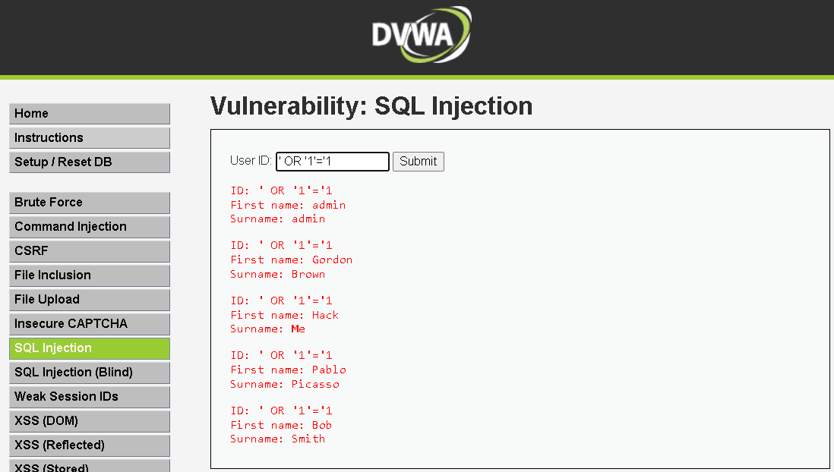

SQL Injection using sqlmap
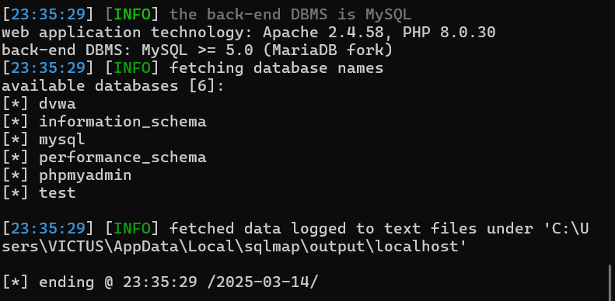
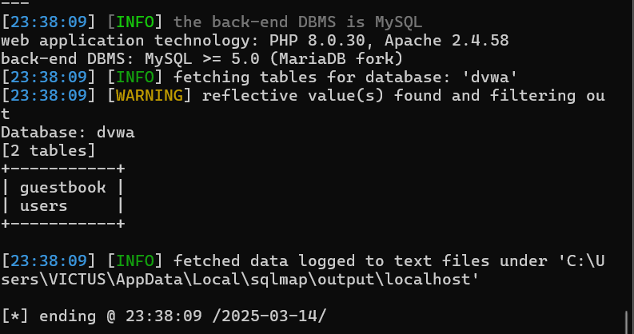
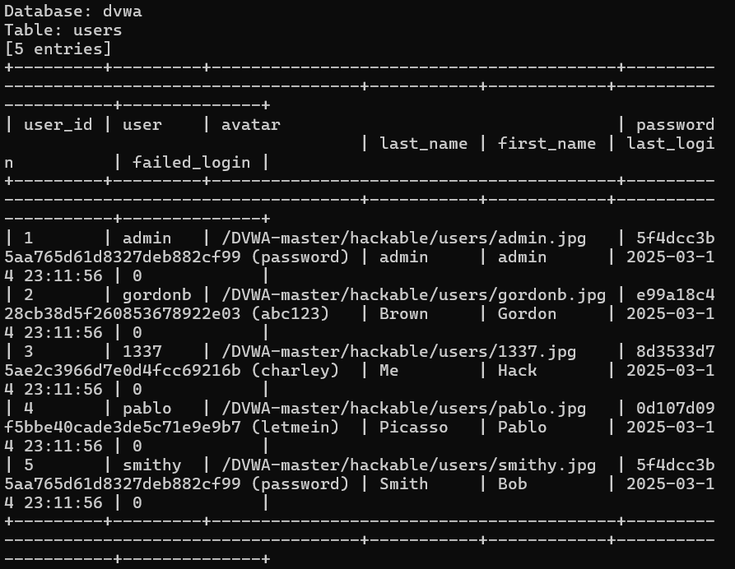
--------------------------------------------------------------------------------------------------------------------------
2.Burp Suite for Web Traffic Analysis
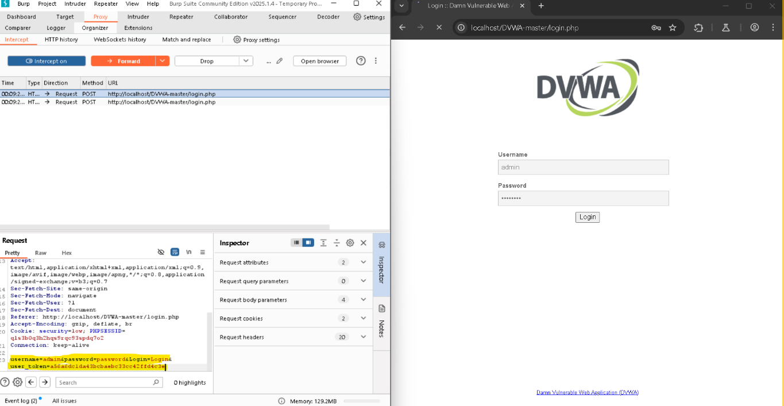
--------------------------------------------------------------------------------------------------------------------------
3.Web Scrapping Tool: 


